Configuring route to Website in Hamburg via MPLS.

Need to get to <http://mercgfa03.ov.otto.de:11100> from VDI vlans

On Listerhills Core Switches

route via PCI Firewall;

ip route 10.32.40.33 255.255.255.255 172.16.32.209

On Hamburg Demarcation switches

route to Hamburg Firewall Cluster Address;

ip route 10.32.40.33 255.255.255.255 10.108.34.3

This the advertises the route back to the Listerhills demarcation switches.

# On PCI Firewall;

Added host to group otto_networks for firewall rule.

Added route to fghfw31

10.32.40.0 255.255.255.0 – 10.227.178.1

Added to DNS

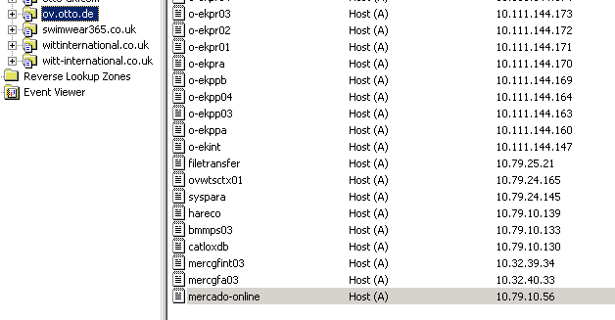

# Anti Spoofing

Add to mpls_all group on firewall to stop anti spoofing.